Docker Tutorial Series

Romin Irani My passion is to help developers succeed. ¯\_(ツ)_/¯

Unless you have intentionally decided to block any news around software in your social feeds, it is likely that you have heard about Docker.
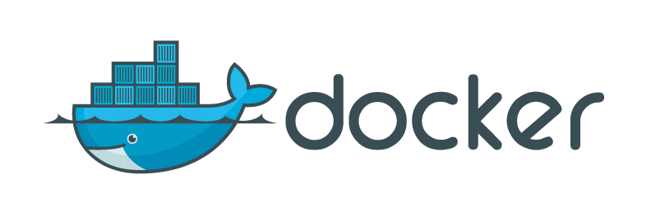
I have written a few posts around Docker and how you can get started with it, but those were more from the point of selecting an OS to learn Docker and so on. Nothing about the details. In the meanwhile, there are tons of excellent resources available to learn Docker from scratch and I have been lucky to read those resources and learn from them.
I have been collecting a lot of notes around Docker and decided that it is time that I publish a series of tutorials on Docker. True to my style, I prefer doing 101 tutorials and want as many people to get started on any technology. And this tutorial will be no exception. I plan to publish at least 10–12 parts on Docker to help you come up to speed with it.
Before I start, I strongly recommend that do not dismiss this technology. Docker has been revolutionary in many ways and it presents a standard way to build/package/ship your applications in a portable format. And there are tons of use cases that you could use Docker for. If you want to read about some of them, try my Docker Use Cases blog post.
And keep checking back for more sessions as they get added:
Update:
December 31, 2017 : Parts 1–9 updated with new screenshots and removal of boot2docker references.
31 January 2017: Added Docker Management Commands (Part 13)
- Part 1 — Installation
- Part 2 — Basic Commands
- Part 3 — More on Images and Containers
- Part 4 — Docker Hub
- Part 5 — Building your own Docker Images
- Part 6 — Docker Private Registry
- Part 7 — Data Volumes
- Part 8 — Linking Containers
- Part 9 — Writing a Dockerfile
- Part 10 — Docker Swarm Tutorial
- Part 11 — Docker Swarm on Google Compute Engine
- Part 12 — Getting Started with Kubernetes using Minikube
- Part 13 — Docker Management Commands
- Appendix
- Docker : Learning Resources
- Docker Use Cases
- Learning Docker ? Move To The Cloud !
Hope you enjoy the series and learn about Docker. Feel free to reach out if you have any issues with the tutorial. All mistakes are mine.

